|  |  |
| --- | --- |
|  | **Horizon College of Business and Technology**  **Faculty of Information Technology**  **BSc (Hons.) in Information Technology/BIT (Hons.) in Networking and**  **Mobile Computing** |

Please fully complete all sections as requested.

|  |  |  |
| --- | --- | --- |
| **Degree Program: BIT (Hons) in Networking & Mobile Computing** | | |
| Research Details | | |
| **Student Details / Group Name:** | | |
| Name with Initials | Registration No | Phone No |
| A.K. Ranaweera | ITBNM-2110-0046 | **0705718977** |
|  |  |  |
|  |  |  |
| **Primary Supervisor** | | |
| Name with Initials | Email | Phone No |
| **Pubudu**  **Malith Nallaperuma** | malith.mihiran@horizoncampus.edu.lk |  |
| **Co-supervisor / Mentor (if any)** | | |
| Name with Initials | Email | Phone No |
|  |  |  |
|  | | |
| **Proposed Research Project Details:** | | |
| **1. Working Title** | | |
| **Microcontroller-Driven Indoor Hydroponic Fodder System** | | |
|  | | |
|  | | |
| **2. Problem Statement** | | |

People in many urban areas struggle to grow their own fresh produce due to limited space, unsuitable soil and the time-consuming nature of traditional gardening. While traditional hydroponic systems can help, they often require human intervention and expertise. There is a need for a user-friendly automated hydroponic system that can be controlled and monitored via a mobile app and can be used by even novice growers. The project aims to develop a

|  |
| --- |
| smart, automated hydroponic system controlled by an app to monitor and adjust key parameters such as nutrient levels, pH, temperature, power and lighting to ensure optimal plant growth. The system will provide users with a convenient and effective way to manage their indoor gardens, making urban farming more sustainable and accessible. |
| **3. Research Aim** |
| The research aims to create an app-controlled automated hydroponic system to maximize plant growth in urban environments. The main objectives include system design, smart control implementation, effect evaluation, user feedback evaluation and exploration of the potential of urban agriculture. |
|  |
|  |
| **4. Research Objectives** |
| This should specify the research objectives that are consistent with the overall research objectives.  In this section, state the specific, measurable goals to be pursued to achieve the overall goals of the study. These objectives serve as a roadmap to guide the research process and describe the desired results. Each goal should be clearly defined and structured to facilitate systematic evaluation of progress and achievement. |
| * **Objective 1:** Design and implement an automated indoor hydroponic system for growing fodder. * **Objective 2:** Integrate a microcontroller to monitor and control environmental factors such as light, temperature, humidity, and nutrient levels. * **Objective 3:** Develop a user-friendly interface for managing and adjusting system parameters. * **Objective 4:** Ensure the system is cost-effective, sustainable, and scalable for various applications. |
|  |
| **5. Research Questions** |
| This should specify the research question you will seek to answer.  In this section, the specific questions that will guide the research process and provide focus for the investigation are articulated. These questions should be formulated to address key aspects of the research objectives, guide the collection and analysis of data to gain meaningful insights, and establish the design, concept, or implementation. |
| Question 1: Considering factors such as plant needs, system complexity, and energy consumption, which hydroponic technology is best suited for the proposed appcontrolled automated hydroponic system? |

|  |
| --- |
| Question 2: How to design a hydroponic system to be modular, scalable, and energy-efficient while ensuring seamless integration with mobile applications for remote monitoring?  Question 3: What sensors and actuators should be integrated into the system to enable automatic monitoring and control of key parameters such as nutrient concentration, pH, water temperature and lighting?  Question 4: What are the optimal growing conditions (e.g., nutrient levels, pH, temperature, light) for the selected plant species? |
|  |
| **6. Background Literature Review** |

The development of hydroponic systems has a been extensively studied for its potential in solving agricultural challenges, especially in areas with limited water and land resources. This literature review highlights key research and advances in the field of a automated hydroponic systems, particularly those focused on feed production.

1. Automation system based on IoT

Muhammad E. H. Chowdhury et al (2020) explored the design, construction and testing of an automated IoT-based indoor vertical hydroponic farming test bed in Qatar. The system uses IoT technology to manage and monitor hydroponic operations, making it suitable for arid environments.

1. Mobile application integration

Kunyanuth Kularbphettong and colleagues (2019) developed an automated hydroponic system based on a mobile app in Thailand. The system is designed to increase user convenience and productivity through remote control and monitoring of hydroponic systems, including automatic nutrient replenishment and environmental adjustments.

1. Nutrient and moisture management

Shreya Tambay et al. (2019) proposed an automated hydroponic system based on the Internet of Things, focusing on the precise management of water and nutrient solutions. The system automatically adjusts nutrient delivery and monitors environmental conditions to optimize plant growth

The development of small-scale indoor hydroponic feed production systems covers various studies highlighting the importance and effectiveness of hydroponic systems in feed production, especially in areas with limited land and water resources.

|  |
| --- |
| 1. Nutrient composition and digestibility: Dung et al. (2010) studied the nutritional composition and Sacco digestibility of barley grains and malted barley, emphasizing the nutritional benefits of hydroponic feeds. 2. Evaluation of hydroponic feed production: Bakshi et al. (2017) conducted a critical evaluation of hydroponic feed production, highlighting the efficiency and high yield potential of this method compared to conventional feed production methods. 3. LEDs for hydroponic growth: Kobayashi et al. (2013) explored the use of lightemitting diodes (LEDs) to grow hydroponic lettuce, a method that could be extended to forage crops, demonstrating the role of artificial lighting in indoor hydroponic systems.      1. Climate adaptation of hydroponics: El-Morsy et al. (2013) studied the adaptability of local hydroponic green feed technology under Egyptian conditions as a means of coping with the effects of climate change, demonstrating the flexibility and resilience of hydroponic systems in different climates. 2. Automated hydroponic system: = Jagtap et al. (2018) developed an automated hydroponic system, emphasizing the importance of automation in improving hydroponic feed production efficiency and reducing labor. 3. Seeding rate and water level optimization: Islam et al. (2016) studied the effects of seeding rate and water level on hydroponic feed production and chemical analysis, providing insights into optimal conditions to maximize yield and nutritional quality.      1. Effect of LED light on plant growth: Bian et al. (2018) studied the effects of LED lights on plant growth, nutrition, and energy utilization efficiency, supporting the use of LED lighting in indoor hydroponic systems to improve plant growth and resource utilization efficiency. 2. Effect of LED lighting on crop growth: Promratrak (2017) studied the effect of LED lighting on hydroponic crop growth, further verifying the effectiveness of artificial lighting in indoor hydroponic systems. 3. Solar-Assisted Hydroponic System: Kamat et al. (2018) designed a solar-assisted hydroponic corn feed gadget, demonstrating the potential of integrating renewable energy into hydroponic systems to enhance sustainability. 4. Barley variety evaluation: Al-Karaki and Al-Momani (2011) evaluated the yield and water use efficiency of different barley varieties when grown as green fodder in hydroponic systems. Their research highlights the advantages of choosing the right hydroponic species. |
|  |

|  |  |  |  |
| --- | --- | --- | --- |
|  | | | |
| **7. Data Requirement** | | | |
| In this section, specify the origin of data necessary to achieve the research aim. Provide a brief overview of the planned data collection process, including the nature of the data to be collected and any intended data collection techniques (i.e., Surveys, Interviews, etc.). *(Hint: Select the appropriate data source. If you intend to utilize both primary and secondary sources, select both options.)* | | | |
| **A: Primary Data** | ✔ | **B: Secondary Data** |  |
| **Primary Data**   * **Interviews**: Conduct with stakeholders to understand needs. * **Surveys**: Collect quantitative data on expectations and preferences. * **Site Visits**: Observe existing hydroponic systems. * **Workshops**: Collaborate with experts and users.   **Secondary Data**   * **Document Analysis**: Review literature on hydroponics and related technologies. | | | |
|  | | | |
| **8. Hardware/ Software Requirements** | | | |
| **Hardware**   * Arduino board –( Acts as the central microcontroller to receive inputs from sensors, process data, and control outputs like displays, pumps, or LEDs.) * moisture sensor –( Measures the moisture level in the soil. Commonly used in gardening or agriculture to monitor soil hydration.) * DHT 11 sensor –( Measures temperature and humidity. Useful for environmental monitoring or controlling climate in a controlled space like a greenhouse.) * LCD Display - (Shows information such as sensor readings, status messages, or alerts to the user in a readable format.) * Water leavel sensor –( A water level sensor is a device used to detect and measure the level of water or other liquids within a container, tank, or system. It plays a critical role in monitoring and controlling water levels, particularly in automated systems.) | | | |
| * TDS sensor –( Measures the Total Dissolved Solids (TDS) in water, indicating its purity or contamination level.) * LDR sensor –( Measures light intensity. Can be used for light level detection or to control lighting based on ambient light conditions.) * ESP8266 –( A Wi-Fi module that enables your project to connect to a wireless network for internet access or remote control.) * Turbidity sensor –( Measures the cloudiness or haziness of a liquid. Often used to assess water quality.) * Water pump – (Used to move or circulate water, often for irrigation or hydroponic systems.) * Exhaust Fan –( Provides ventilation to remove heat or fumes, improving air quality in an enclosed space.) * LED –( Light Emitting Diode, used for visual indicators or status lights.) * Battery Pack –( Provides power to the entire system when not connected to an external power source.) * Breadboard and Connecting Wires –( Used for prototyping and connecting electronic   components without soldering.) | | | |
| **Software**   * Arduino IDE (Designed for C++ Adriano.) * Web site Development Platform (e.g. Visual studio, (c++,html) ) * Cloud Service (e.g.,firebase ) • | | | |
|  | | | |
| **9. Ethics** | | | |
| Sustainable Development and Environmental Responsibility -  Resource Conservation: This system should be designed to minimize water and energy consumption, aiding in permaculture practices. | | | |

Waste management: Proper disposal and recycling of electronic components and nutrient solutions should be ensured to prevent environmental pollution.

1. Safety and Reliability

Ensuring the safety and reliability of the system is paramount, especially when dealing with automated processes. The microcontroller-driven system must be designed with fail-safes and

|  |
| --- |
| redundancy to prevent malfunctions that could harm plants, people, or equipment. Regular testing and maintenance protocols should be in place to guarantee consistent and safe operation over time. Power outages or hardware failures should be handled gracefully to avoid crop losses.     1. Responsibility and Liability   As the developer of this system, you are responsible for its design, implementation, and performance. Liability arises if the system causes any harm to users, animals consuming the fodder, or the environment. Proper documentation, user training, and instructions should be provided to minimize misuse. If any faults or risks are identified, it is the developer's ethical duty to address them promptly and transparently.     1. Environmental Impact   Hydroponic systems generally reduce water usage and avoid soil degradation, offering an environmentally friendly solution. However, the energy consumption of the indoor system, particularly for lighting and temperature control, must be managed efficiently. Ethical considerations should include minimizing the system's carbon footprint by using renewable energy sources where possible and optimizing resource use to avoid waste, contributing to overall sustainability. |
|  |
| **10. References** |

|  |
| --- |
| References     1. A. J. a. K. K. S. Adarsha Gopalakrishna Bhat*, "Development of Small Scale Indoor Hydroponic," p. 06, 02 09 2021. 2. S. B. J. P. M. V. M. N. G. Sandip S. Turakne, "Hydroponics Fodder Grow Chamber," p. 5, june 2021. 3. T. M. ,. D. ,. T. F. Sisay Bedeke Bedeke, "Impact of adoption of hydroponic fodder production," p. 26, 12 june 2024. 4. J. S. ,. X. W. 2. B. Z. Jinyu Yang, "Light Intensity Affects Growth and Nutrient Value of," p. 17, 22 may 2024. 5. S. K. R. W. K. H. B. W. C. T. Surateno, "Portable automatic nutrient mixing based on microcontroller," p. 11, 2024. 6. W. Soufan, "The Effect of the Mixing Ratio of Barley and Mung Bean Seeds," p. 14, 31 August 2023. 7. A. N. H. M. R. D. P. U. S. Y. F. N. P H Ndaru, "Providing High Quality Forages with Hydroponic Fodder System," p. 7, 2020. 8. S. R. F. R. N. I. A. N. Azhari*, "PENDAMPINGAN TEKNOLOGI HIDROPONIK FODDER DI GAMPONG COT KARIENG KECAMATAN BLANG BINTANG, ACEH BESAR," p. 5, 25 08 2023. 9. *. ,. F. I. Z. 2. S. A. A.-K. Nagat Ahmed Elmulthum, "Water Use Efficiency and Economic Evaluation of the," p. 13, 03 January 2023. 10. V. R. M. T. R. K. a. M. S. S. Shanmuga Sundaram A, "Performance and economics of feeding soviet chinchilla rabbits with," p. 5, 23 04 2023. |
| **11. Gantt Chart**    **Gantt Chart for Development** |

**Gantt Chart for Writing Dissertation**

**Block Diagram**

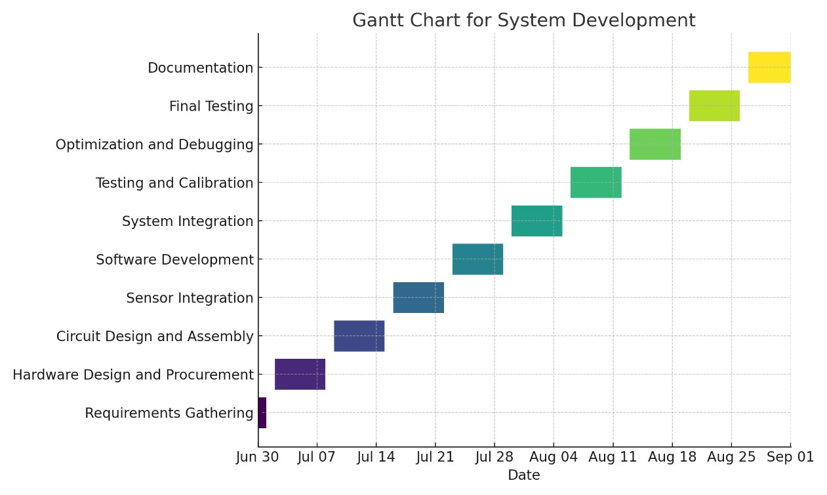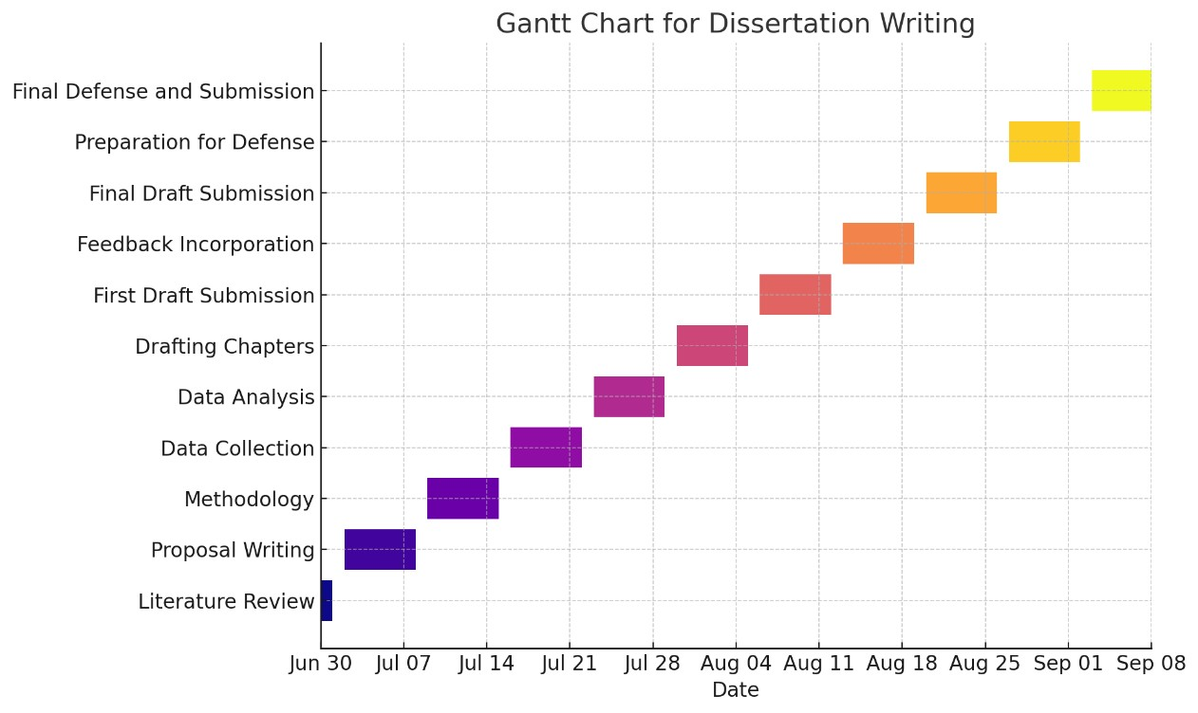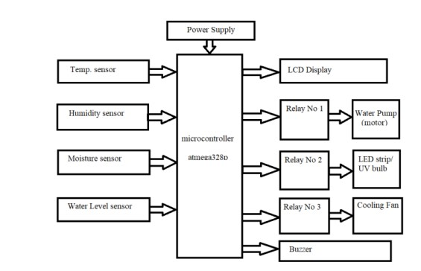

|  |  |  |
| --- | --- | --- |
| Students Agreement: | | |
| By signing below on <26/06/2024> , I/We, as A.K.Ranaweera , (name/s) agree to the commonly known and accepted research ethics and guidelines. I/We commit to conducting the research project as mentioned above and outlined in the agreement. I/We understand that any changes to the group composition, identified research problem, or selected supervisor may result in penalties. | | |
|  | | |
| Name with Initials | Registration No | Signature |
| A.k.Ranaweera | ITBNM-2110-0046 |  |
|  |  |  |
|  |  |  |
|  | | |
| Supervisor(s) Agreement: | | |
|  | | |
| By signing below, I/We agree to supervise the aforementioned group of students throughout their research project, providing guidance and support for successful completion.  Furthermore, by signing this document, I/we give my/our consent to the following:   1. The identified research problem is justifiable and feasible for investigation. 2. The research aim is achievable within a one-year timeframe. 3. The specified research objectives are measurable and achievable within the research period. | | |
| Supervisor’s Name with Initials | Signature | Date |
| **Pubudu Malith Nallaperuma** |  |  |
|  |  |  |
|  |  |  |
| Departmental Use Only: | | |
| **Date Proposal Form Submitted:**    All required sections of the form have been accurately completed, and the necessary signatures have been placed. The initial research proposal has been partially approved, thereby allowing the proposed research project to proceed in accordance with the specified guidelines outlined in the IT41028.        **Research Coordinator’s Signature: Date:**        **Department Head’s Signature: Date:** | | |